Knee Rehab
Quad Stretches:
- Lying Side Quad Stretch: Lie on one side. Grasp top ankle or forefoot behind. Pull ankle or forefoot to rear end. Straighten hip by moving knee backward. Hold stretch. Repeat with opposite side.
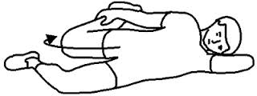
- Standing Quad Stretch: While standing, bend your knee back by grasping your ankle with one hand. Assist in bending your knee back as far as possible.
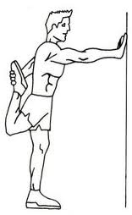

- Kneeling Quad Stretch: Position yourself with one knee on the floor and the other leg out in front with the knee bent and foot flat on the floor. Grasp the ankle of the back leg behind you. Lean forwards from the hips and at the same time pull the ankle towards your buttocks. When you can start to feel a stretch in the front thigh, hold the position.
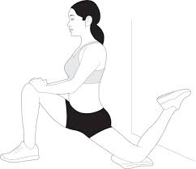
Hamstring Stretches:
- Scissor Hamstring Stretch: Stand with your feet together. Step your right foot back about two feet and bend forward from your hip joint, keeping your back and both legs straight. After holding for 30 seconds, switch sides.
