Lower Back Rehab
Stretches:
- Back Flexion Exercise: While lying on one’s back, pull both knees to the chest while simultaneously flexing the head forward until a comfortable stretch is found in the a balled-up position.
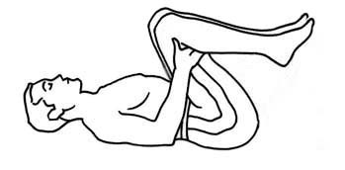
- Knee to Chest Stretch: While lying on back with knees bent and both heels on the floor, place both hands behind one knee and bring it to the chest.
- Prone Press Up: Begin by lying on your stomach with your elbows bent underneath you and palms flat on the surface. Keeping your hips and pelvis in contact with the surface, lift your upper torso off the mat with your arms, keeping your back muscles relaxed. Only go as high as you are comfortable.
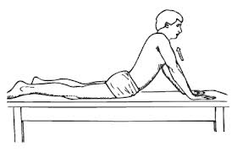
Prayer Stretch: On your hands and knees, sit back so your buttocks are resting on your heels. Reach your hands forward to lengthen your spine and feel a stretch in your middle back. You can reach your hands to either side to focus the stretch on the opposite side of your spine.
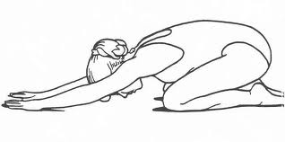
Cat Stretch: On your hands and knees, let your belly sag towards the table to increase extension through your spine). To increase flexion through your spine, arch your back upwards, bringing your spine away from the table.
