Shoulder Rehab
Stretches:
- Shoulder Blade Squeezes: Begin sitting or standing tall with your back straight. Squeeze your shoulder blades together until you feel a mild to moderate stretch.
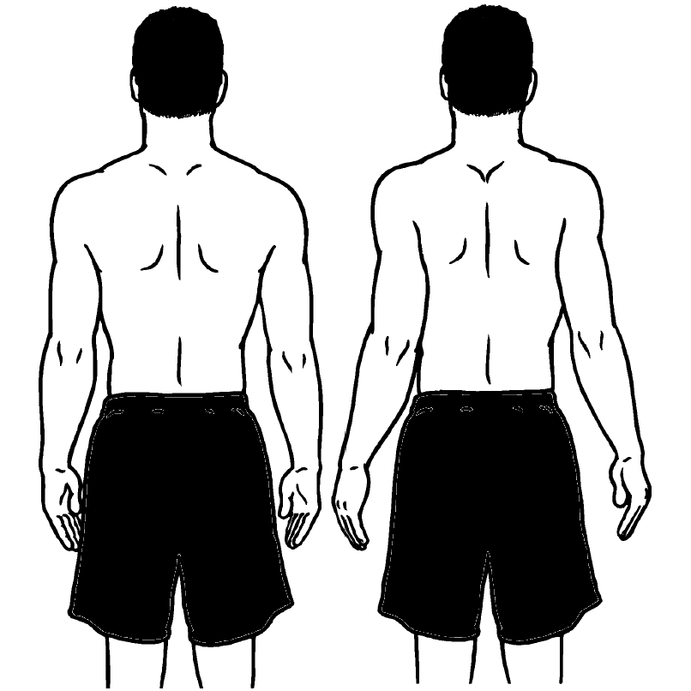
- Shoulder Flexion: Begin standing tall with your back and neck straight, gently raise your arm forward and up until you feel the mild to moderate stretch pain free.
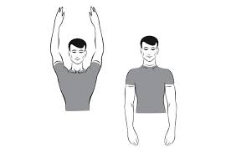
- Cross-Arm: Reach across the chest as if to bring the elbow toward the opposite shoulder. Grasp the elbow and pull gently in that direction.
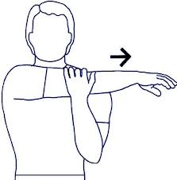

- Pendulum Exercise: Bend forward 90 degrees at the waist with your uninjured arm on a chair or table for support. Let your injured arm hang down toward the ground. Make small circles with the hand of your injured arm.
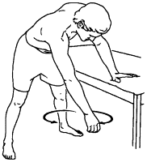
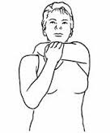
- Posterior Stretching Exercise: Hold the elbow of your injured arm with opposite hand, use your hand to pull your injured arm gently up and across your body. You will feel a gentle stretch across the back of your injured shoulder.

